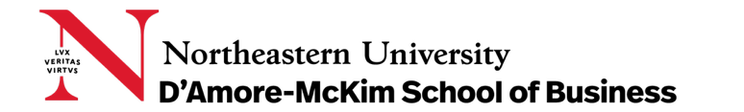

FINA 6213 – Investment Banking

Mars Inc - The Acquisition of Wrigley

Presented to:
Prof. Serdar Aldatmaz

Presented by:
Jake Higgins
Khushi K
Niramay Prashant Lakhani
Suhani Panchal
TABLE OF CONTENTS

1. Executive Summary 3
2. Advantages and Disadvantages of the Merger 3
3. Deal Overview 5
4. Valuation for Wrigley 7
5. Valuation Analysis 10
6. Conclusions and Final Recommendations 12
7. Appendix 13

Executive Summary
This valuation report examines the proposed merger between Mars Incorporated and Wrigley Company, a potential landmark transaction in the global confectionery industry. Mars, as the acquirer, seeks to integrate Wrigley’s category leadership in gum and mints with its own dominant chocolate portfolio to build a fully diversified confectionery powerhouse.
The report provides an overview of both companies, outlines the strategic rationale for the merger, and evaluates the advantages and disadvantages for each party. It then presents the valuation framework and methodology applied by our team, including sensitivity analyses that assess how variations in key assumptions affect the valuation outcome. These analyses form the basis for our final recommendation regarding the appropriate offer price range.
The merger between Mars and Wrigley represents more than financial synergy; it is a move to strengthen market leadership, expand geographic reach, and balance product portfolios in a mature but resilient industry. This report delivers a rigorous, data-driven assessment to determine the fair value of Wrigley and to guide Mars in structuring a disciplined and strategic offer.

Advantages and Disadvantages of the Merger

2.1 Advantages of the Merger
1. Strategic Advantages
The Mars–Wrigley merger in 2008 was a transformational step that made Mars the largest confectionery company in the world. Mars dominated chocolate with brands like Snickers and M&M’s, while Wrigley led the gum market with Orbit and Extra. Their products complemented each other perfectly, offering a complete mix without overlap. The merger strengthened Mars’s position in Eastern Europe and Russia through Wrigley’s networks and expanded Wrigley’s access to Asia, China, and India via Mars’s distribution strength. It also protected both firms from competitors like Hershey, Cadbury, and Nestlé, who were considering alliances of their own. Beyond scale, the deal balanced Mars’s traditional chocolate base with Wrigley’s fast-growing, health-aligned gum segment, capturing changing consumer preferences. This combination of scope, geography, and diversification gave Mars the strategic edge to reclaim global leadership and secure long-term market growth.
2. Operational Advantages
Operationally, the merger created large efficiencies across sales, production, and distribution. Mars and Wrigley both sold in similar markets, and combining these channels reduced duplication and lowered administrative costs by an estimated 7–11%. Wrigley’s 66-day cash cycle could improve further using Mars’s systems, freeing roughly 15% of working capital. On the manufacturing side, Wrigley’s spare plant capacity could produce Skittles and Starburst, saving about $50 million after tax and eliminating the need for new equipment. Together, they gained stronger bargaining power with suppliers, allowing bulk purchasing of sugar, packaging, and flavors. Shared marketing and logistics further enhanced cost control. These measures would make the merged company leaner, faster, and more efficient—achieving significant savings while keeping quality high and ensuring both brands maintained their reputation for reliability and consistency in global markets.
3. Financial Advantages
Financially, the merger offered clear rewards for both parties. Wrigley shareholders benefited from an all-cash deal that paid a premium over the market price, providing the family immediate liquidity. For Mars, the acquisition added a steady, recession-resistant cash flow from gum and mints, which complemented its more cyclical chocolate revenues. To fund the purchase, Mars worked with Goldman Sachs and Berkshire Hathaway, taking on debt for the first time while keeping full family ownership. This upheld its core belief in “freedom to shape our future.” Expected cost savings and efficiency gains were already built into the valuation, increasing Wrigley’s worth beyond its stand-alone level. The merger thus combined immediate value realization for Wrigley with long-term cash generation and financial flexibility for Mars, strengthening its position as a disciplined yet growth-focused private enterprise.
4. Cultural and Organizational Advantages
The merger succeeded culturally because Mars and Wrigley shared strong family-based values built on quality, responsibility, and mutual respect. Mars honored Wrigley’s identity by allowing it to remain an independent subsidiary, maintaining its leadership, culture, and brand name. William Wrigley Jr. II stayed on as Executive Chairman, providing continuity and confidence during the transition. Retaining Wrigley’s experienced team preserved its innovative spirit, supported by the Global Innovation Center and Wrigley Science Institute. Both companies also had reputations for ethical business practices and community involvement, with Mars guided by its Five Principles and Wrigley deeply involved in Chicago philanthropy. Their shared approach to people and performance made the merger a genuine alignment of purpose, creating a unified organization rooted in trust, tradition, and long-term responsibility to employees, customers, and society.
5. Governance and Control Advantages
The merger also strengthened Mars’s governance and control. Earlier attempts at partnership failed because Mars was unwilling to share internal information, but full acquisition removed that barrier. By bringing Wrigley completely under its ownership, Mars could make decisions independently without external interference. This suited its culture of privacy and self-reliance, keeping operations confidential and free from public market scrutiny. Remaining privately held allowed Mars to avoid quarterly reporting pressures and maintain its long-term focus. Financing through trusted partners like Berkshire Hathaway ensured stability without giving up ownership. The result was a company that achieved integration without losing independence—uniting two respected confectionery leaders under one vision while protecting Mars’s defining principle of freedom through family ownership and full control over its future direction.
2.2 Potential Downside to Wrigley
1. Growing Competitive Pressure
If Wrigley chose to remain on its own, it would have faced tough competition from much larger players like Cadbury, Hershey, and Nestlé, who were rapidly expanding through mergers. With fewer resources and a smaller product lineup, Wrigley could have struggled to match their global marketing power and pricing strength. A potential Cadbury–Hershey merger would have made it even harder for Wrigley to compete on equal footing in both scale and reach.
2. Slower Global Growth
Wrigley had strong positions in Eastern Europe and Russia, but its presence in Asia and other fast-growing regions was limited. Without access to Mars’s well-established distribution in China and India, the company risked missing the biggest growth opportunities in the confectionery market. Remaining independent would have kept Wrigley tied to slower-growing, mature markets, restricting its ability to expand and diversify its revenue base globally.
3. Narrow Product Focus
As a company built mainly around gum and mints, Wrigley faced the challenge of relying too heavily on a single product category. Consumer tastes were shifting, and growth in gum was beginning to slow, especially in developed countries. Without merging, Wrigley would lack the variety and stability that Mars’s broader confectionery range offered, leaving it more vulnerable to changing trends and limited in long-term growth potential.

Deal Overview

Transaction Summary
- Parties: Mars, Incorporated (Acquirer) and Wm. Wrigley Jr. Company (Target)
- Date: April 2008 (negotiations culminating April 12, 2008)
- Transaction Type: Friendly cash acquisition/merger
- Strategic Significance: The merger would create the world's largest confectionery company, combining Mars's $25 billion global operations with Wrigley's $5.4 billion business.

  - Key Deal Characteristics
Deal Rationale:
- Mars would become the undisputed global confectionery leader, surpassing rivals Cadbury and Hershey
- Complementary product portfolios with minimal overlap (Mars dominated chocolate; Wrigley led chewing gum with 36% global market share)
- Geographic synergies: Wrigley's strength in Eastern Europe/Russia complemented Mars's dominance in Asia
- Mars had explored joint venture options since 2005 but concluded full acquisition was necessary to realize synergies without information disclosure concerns
Deal Structure:
- All-cash transaction to avoid diluting Mars family ownership
- Financing: Mars would break its century-long no-debt policy, securing syndicated loans from Goldman Sachs and Berkshire Hathaway
- Required approval from Wrigley family (controlling 70% voting rights through Class B shares)
Strategic Context:
- Both companies were family-owned with strong cultural traditions
- Mars held 11% global confectionery market share; Wrigley ranked fourth largest confectionery company
- Deal would strengthen competitive position against Cadbury (threatening Hershey merger talks) and Hershey in key markets
- Combination would create enhanced distribution capabilities and negotiating power with retailers
This transaction represented a transformative moment in confectionery industry consolidation, combining two iconic American family businesses with complementary strengths across products and geographies.

Valuation for Wrigley

Valuation Summary
We valued Wrigley with the Discounted Cash Flow (DCF) Method by discounting its Free Cash Flows by the required rate of return which is Weighted Average Cost of Capital (WACC) for the company. Our forecast horizon was 5 years and all Cash Flows beyond that were calculated in the Terminal Value.

  - Valuation Inputs
Our DCF Model was built on certain specific inputs that we calculated and analyzed based on the case study and the exhibits given in the case. The inputs that were required for the case were:

- Beta
- Risk-Free Rate
- Market Risk Premium
- Cost of Equity
- Weight of Equity

- Cost of Debt
- Weight of Debt
- Tax Rate
- Terminal Growth Rate
- WACC

- $βeta$, Risk-Free Rate, Market Risk Premium and Cost of Debt
Many of the valuation inputs were already given in the case study and its exhibits so we directly used them as is, such as values for $βeta$, Risk-Free Rate, Cost of Debt and Market Risk Premium. The $βeta$ of the company was 0.7. We took the 10-year T-Bill Interest Rate as our Risk-Free Rate which was 3.68% and the Market Risk Premium was 6%. To get the Cost of Debt, we checked the Bond Rating for Wrigley which was ‘A’. Bonds with similar rating were being traded in the market at 6.30%
- Cost of Equity
To find the Cost of Equity, which was 7.88% we used the CAPM formula. We multiplied the Market Risk Premium with the Beta and added that value to the Risk-Free Rate.
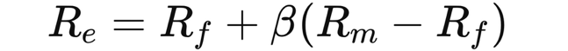

$$R_{e} = 3.68\% + [ 0.7(6\%) ] = 7.88\%$$

- Weight of Equity and Debt
To calculate Weight of Equity and Debt, we used the Market Cap and Long-Term Debt as values for each and divided them by the Total Capital (Equity + Debt). Values for both can be found in Exhibit 2
Weight of Equity:
$\frac{Market Captalization}{Total Capital}$ = $\frac{15,899}{15,899 + 1,000}$ = 94.08%
Weight of Debt:
$\frac{Long-Term Debt}{Total Capital} = \frac{1,000}{15,899 + 1,000}$ = 5.92%
Through these figures, we arrived at the Weight of Equity as 94.08% and Weight of Debt as 5.92%

- Terminal Growth Rate and Tax Rate
The Case also gave Tax Rate as 32% and the Terminal Growth Rate as 5.60%.

- Weighted Average Cost of Capital (WACC)
Using all the inputs from above, we calculated the Weighted Average Cost of Capital (WACC) using the following formula:
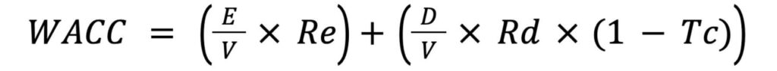

WACC:

$$WACC=\left[ 0.9408 7.88\% \right]+\left[ 0.0592 \left( 1 - 0.32 \right) 6.30\%\right]$$
$$= 7.67\%$$

Calculating Terminal Value

Our forecast horizon was 5 years. Anything Cash Flow beyond Year 5 has been accounted for in the Terminal Value. We needed 3 things to calculate Terminal Value:

- Free Cash Flow in Year 6
- WACC
- Terminal Growth Rate
We used the following formula to calculate Terminal Value:
$$TV = \frac{{FCF}_{5}×\left(1+TerminalGrowthRate\right)}{WACC - Terminal Growth Rate}$$
Terminal Value:
$$TV = \frac{\$726 × \left(1+0.056\right)}{0.0767 - 0.056}= \$37,087$$

  - The Discounted Cash Flow Analysis

After getting all the inputs required for DCF Analysis, we now move onto it. Taking the Free Cash Flow for all the years and the Terminal Value for the years beyond our forecast horizon, we now multiply them with the discount factor, which is the discounted value of $1 by the WACC. Doing this, we get the Present Value (PV) of all our Cash Flows.

After getting the PV of all Cash Flows, we simply just sum them up to get the Enterprise Value of the Company (EV): $27,998.68

  - Price per Share

Now that we have got the Enterprise Value, we can easily calculate the price which we can assign to each share of the company for its valuation. The Enterprise Value formula is as follows:

$$Enterprise Value \left(EV\right)= Equity Value + Debt Value - Cash \& Cash Equivalents$$

Rearranging the Equation, we get the Equity Value of the company as:

$$Equity Value = Enterprise Value (EV) - Debt Value + Cash \& Cash Equivalents$$
After we get the Equity Value of the Company, we just need to divide that by the Number of Outstanding Shared in the Market. Doing so, give us Price per Share of the company at $98.49. The calculation is shown in the following table.
  - Determining the Multiples
Now that we have calculated the most important part of our valuation, Price per Share, it’s time to calculate the ratios related to it so it helps when we do a comparable company analysis. We are going to calculate two ratios for our firm: 1) P/E Ratio and 2) EV/EBIT Ratio.
  - Price-to-Earnings Ratio
$P/E Ratio = \frac{Price per Share}{Earnings per Share}$

Earnings per Share Calculation

$$EPS = \frac{Net Income}{No. of Shares Outstanding}= \frac{\$632,000,000}{275,742,319} = \$2.29$$
P/E Ratio Calculation

$$P/E Ratio = \frac{\$98.49}{\$2.29}= 42.97$$

  - EV/EBIT Multiple

The second multiple we are calculating is the Enterprise Value-to-EBIT multiple. We already calculated the EV as $27,998.68. The value for EBIT is given in the exhibits as $963, table for which has been attached below.

EV/EBIT Multiple Calculation:

$$EV/EBIT Multiple = \frac{\$27,998.68}{\$963} = 29.0$$

Valuation Analysis
After completing the Standalone DCF valuation for Wrigley, it was important for our team to conduct a sensitivity analysis. While valuating Wrigley (“the target”), key assumptions were made about the terminal growth rate, and we used a WACC calculation based on the information provided in the case study. As any analyst or banker may know, it is important to run a sensitivity analysis on the variables used in the valuation to gain a more complete understanding of the target’s value – given the variables used.
First, the standalone DCF valuation values the target at $98.49 per share. This is using the given terminal growth rate of 5.60% and the calculated WACC of 7.67%. As stated in the case, “For a mature industry, the global confectionery market had a relatively high annual growth rate of 5.60%.”
However, in order to create a well-rounded and accurate valuation proposition to Wrigley, our team decided to run a sensitivity analysis on the terminal growth rate and the WACC. Doing so would allow us to see the per share price of Wrigley given lower or higher values of the growth rate and WACC. As seen in Exhibit 6, our team was able to find the share price of the target using a terminal growth rate range from 3% to 6% and a WACC range from 5.50% to 8%. This will prove useful in our final recommendation and potential offer to Wrigley as we will make informed decisions on how we see the future of Wrigley.

  - Synergy Valuation
The case of Mars and Wrigley becomes an interesting valuation when it comes to including the addition of synergies in the valuation. The anticipated benefits from the merger between the two successful companies were significant, with both Wrigley and Mars expecting to reap benefits that increased their value. However, the Mars family was adamant about not considering any synergy value or benefits to their production lines as a result of the merger. This merger was not just influenced by quantitative factors, but there were emotional factors and sentiment involved as well. With that in mind, this section of the Valuation Report looks at the factors affecting the valuation of Wrigley, which includes factors affecting Wrigley’s standalone value, synergy value from market expansion, and synergy value from internal savings.
Given in the case, there are four key synergy categories that we have included in the synergy analysis of Wrigley. First, there would be revenue synergies that would provide a 3-4% top-line boost in the EMEAI region and a 4-5% top-line boost in the Asia region. Next, there would be a 7-11% increase in SG&A savings from the shared sales force and the potential closing of the Chicago headquarters. Not only that, but there would also be a 15% reduction in net working capital (“NWC”) and $50 million in after-tax savings from transferring Skittles and Starburst to Wrigley. To forecast these synergies, our team used the following assumptions: 4% top-line boost for EMEAI revenue, 5% top-line boost for Asia revenue, and 9% for SG&A savings. The addition of these synergies increased FCF for each forecasted year, which will lead to a higher per-share valuation of Wrigley that will be seen in the next section of the report. See Exhibit 7 for the adjustments made for the revenue synergies (in red) and second for the SG&A, NWC and after-tax savings adjustments made (in red).

  - Synergy Valuation DCF Analysis
As seen in the prior section, even though the Mars family did not want to consider any synergy value or benefits, our team believed it was important to value Wrigley with regard to the synergies mentioned in the case. Using the same assumptions and inputs as described for the Standalone DCF valuation, our team ran another DCF analysis using the new, forecasted free cash flows that include the synergies (see Exhibit 8). Evident in the valuation table below, we used the five forecasted free cash flows, calculated the terminal value for Year 6 and beyond, and then discounted them back to the present value using the same WACC of 7.67% that was used in the Standalone DCF valuation. After discounting those values, our analysis team arrived at an Enterprise Value of ~$41.97 billion. Then, adjusting for debt and cash, arrived at an Equity Value of ~$41.13 billion. Finally, dividing the Equity Value by the number of shares outstanding, we arrived at a per-share price value of $149.17 for Wrigley – including the anticipated synergies (see Exhibit 9).

  - Synergy Valuation Sensitivity Analysis
For all the same reasons listed in the “Standalone Valuation Sensitivity Analysis” section, our team performed a sensitivity analysis on the DCF valuation that included the anticipated synergies from the merger. Using the same range for terminal growth rate and the WACC, the sensitivity table below highlights how the per-share price of Wrigley will change as the terminal growth rate and WACC assumptions increase or decrease. Just like the prior sensitivity analysis, this will prove useful in our final recommendation and potential offer to Wrigley as we will make informed decisions on how we see the future of Wrigley (see Exhibit 10).

Conclusions and Final Recommendations
This carefully executed Valuation Report has covered the process of valuing and analyzing the potential merger between Mars and Wrigley. Mars, the buyer, is considering the purchase of Wrigley, the target. The above report has provided a high-level deal overview, an introduction and rationale for the merger that includes advantages and disadvantages and then jumps into an analysis of the standalone valuation of the target and a valuation including potential synergies. Any applicable tables, financials, and schedules can be found in the embedded exhibits.
Based on the standalone valuation and synergy valuation, our analysis team has come to the following recommendation for what per-share price range Mars will be offering to the Wrigley management team:
Price Range: $77 - $98 per-share
From this range, the team’s opening, or low, bid is $77 per share, which represents a 22.5% premium to the current share price of $62.84. The fair, or base, price is $85 per share, representing a 35.3% premium, and the walkaway price is $98 per share which would represent a 55.9% premium. A combination of factors came into determining this price range.
The case made it clear that the Mars family was adamant about not considering any synergy value or benefits to their product lines as a result of the merger. From a valuation perspective, our analysis team had to consider all the factors described throughout this report. Based on our team’s analysis, we believe the recommended price range is fair and justified as we have conducted sensitivity analyses and adjusted the offer range accordingly. A key input to our team discussion and recommendation was the assumption of the terminal growth rate. In 2007, the global confectionery market had a high annual growth rate of 5.60% - which was used for the valuations in this report. However, as the case mentions, the industry’s forecasted growth was expected to “significantly decrease” due to market satiation and a trend towards healthy lifestyles. With that in mind, along with the information detailed in this report, our team came to our final recommendation highlighted in the prior paragraph.

Appendix
  - Exhibit 1
Exhibit 1:

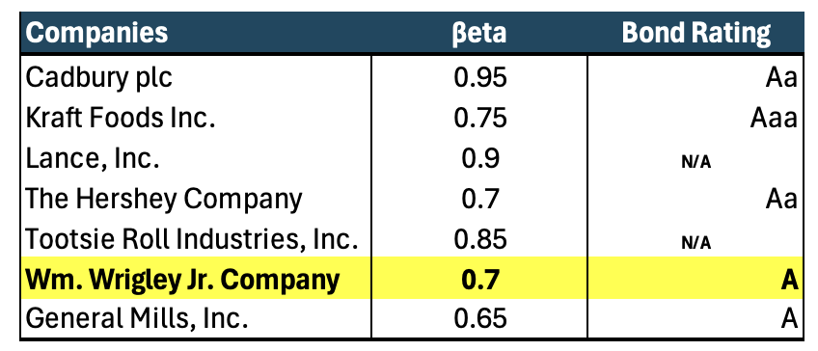
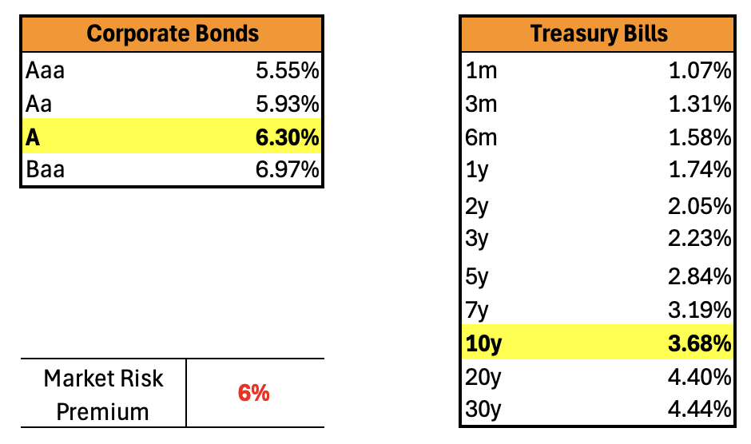

  - Exhibit 2 :
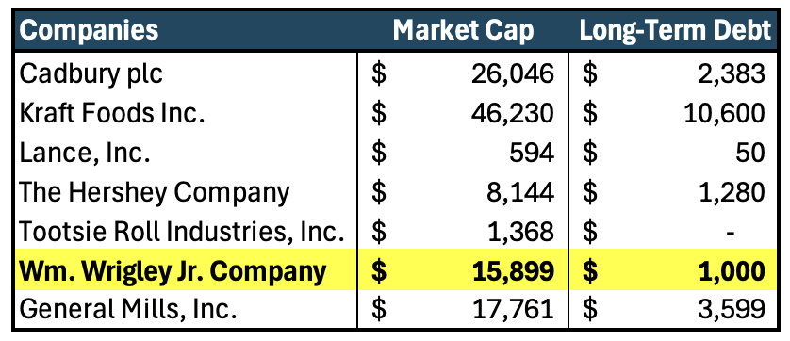

  - Exhibit 3 :

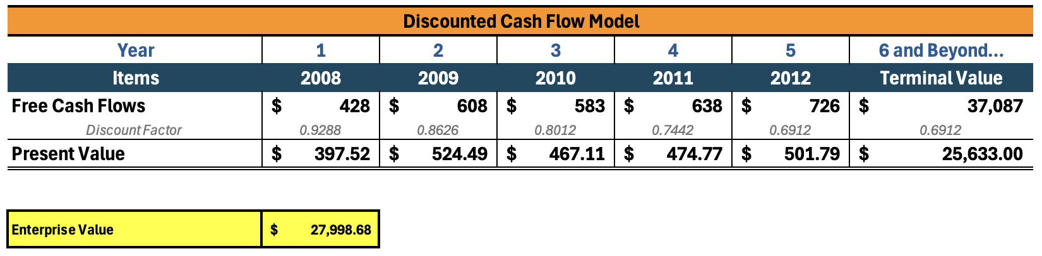

Exhibit 4:
  - Exhibit 4:

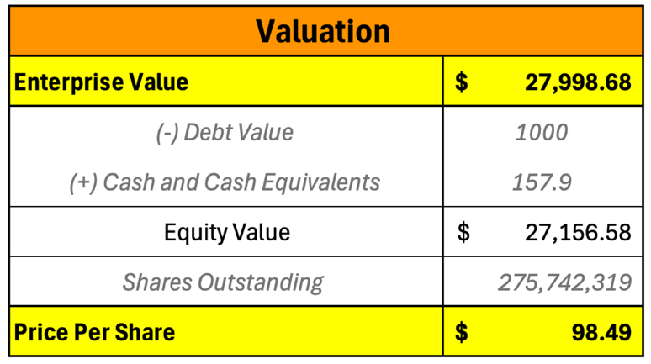

  - Exhibit 5:

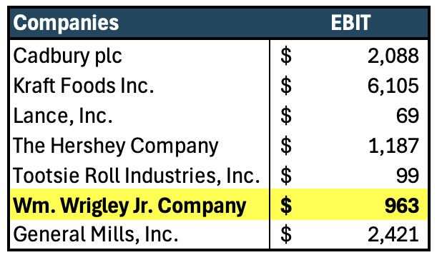

  - Exhibit 6:

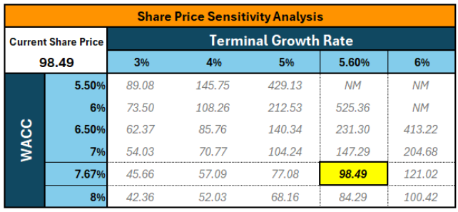

  - Exhibit 7:
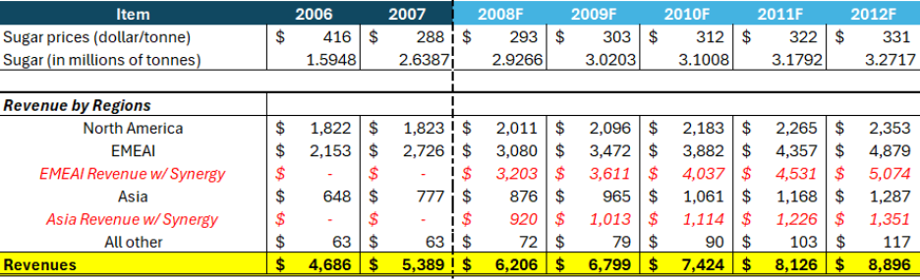

  - Exhibit 8:
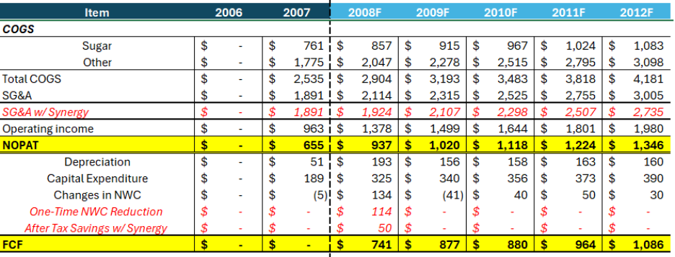

  - Exhibit 9:
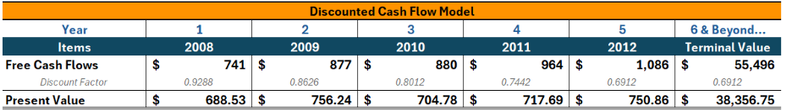

  - Exhibit 10:

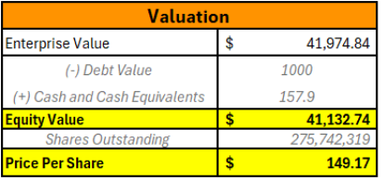

  - Exhibit 11:
